DAY 6 Assignments

Pramit Kumar Bhaduri

Question 1

Create Payload for windows, transfer payload into victim’s machine, exploit.

Payload creation:

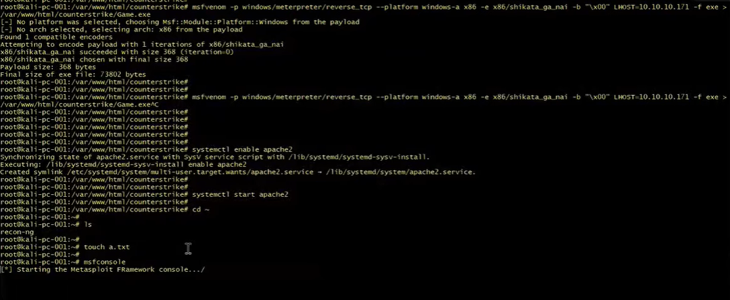

Payload transfer:

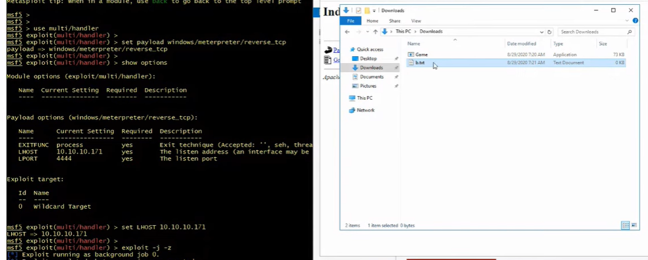

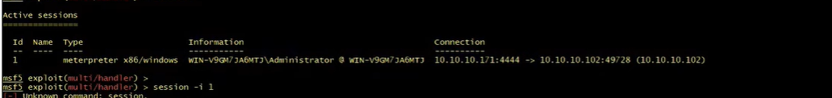

Exploited:

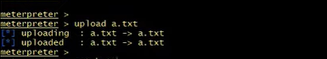

Question 2

Create a FTP server, Access FTP server, Do a mitm attack using Dsniff

